Chair of Space Mobility and Propulsion

Group 4

Technical University of Munich

Full Throttle - Reinforcement Learning - Report Part 2

Practical Course: Control and Simulation of Rocket-Hopper Demonstrator

Anibal Guerrero Hernandez, Hannes Kiefer, and Sven Julius Steinert

October 29, 2024
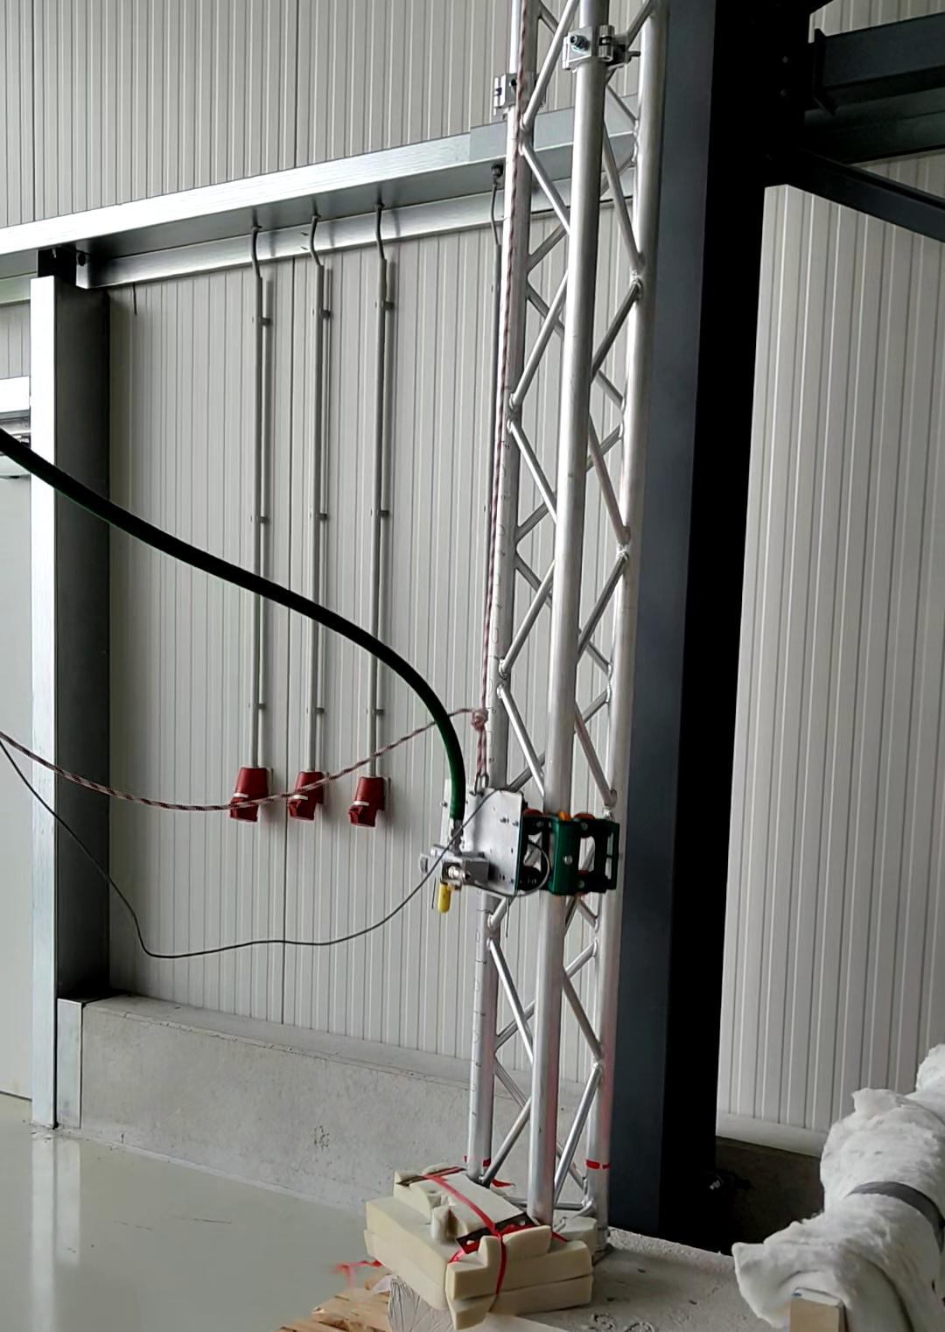

I

1 Introduction

The following report presents an overview of the re-sults of the practical course ”Control and Simulation of a Rocket-Hopper-Demonstrator”.

The course tasks include creating and validating a fluid simulation of the propulsion system, developing a control algorithm for the main valve, and verify-ing models on the hardware demonstrator. The Hop-per is comprised of a platform attached to a vertical track with locked horizontal and rotational degrees of freedom but can freely change its vertical position. It houses a cold gas nitrogen propulsion system supplied by an external tank connected via a flexible hose. Con-trol is achieved by adjusting the entry pressure of the Laval nozzle via a proportional valve with an internal PID controller. The course emphasizes selecting and creating an appropriate controller, where we decide for an experimental algorithm, to use a reinforcement learning (RL) model like DDPG and TD3.

2 Literature

2.1 Reinforcement Learning Model

2.1.1 Model-Free Algorithms

In reinforcement learning (RL), Model-Free RL Algorithms don’t model the environment’s dynamics but focus on learning directly from interactions. They optimize policies or value functions through trial and error, adapting strategies based on ob-served outcomes. This approach is useful for complex environments where accurate modeling is challenging.

Model-Free RL Algorithms concentrate on learn-ing directly from interactions, optimizing policies or value functions without explicitly modeling the en-vironment’s dynamics. They rely on trial and error, adapting strategies based on observed outcomes, mak-ing them suitable for complex environments. Exam-ples include REINFORCE, TRPO, Q-Learning, and SARSA, offering flexibility and adaptability in various real-world applications.

2.1.2 Algorithm Comparison

Two algorithms, DDPG and TD3, are chosen for com-parison. DDPG (Deep Deterministic Policy Gradient) is tailored for continuous action spaces, employing an actor-critic architecture that blends policy-based and

Figure 1 Classification of Reinforcement Learning Algo-rithms, boxing DDPG & TD3 as algorithms of in-terest.
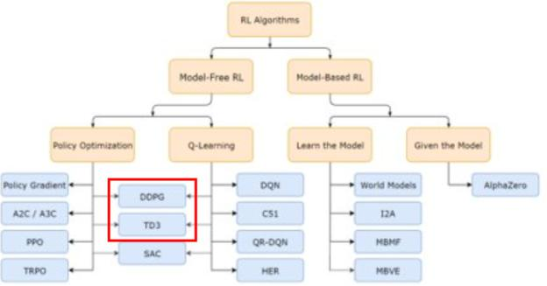

value-based methods. On the other hand, TD3 (Twin Delayed DDPG) extends DDPG, enhancing stability with twin critics and delayed policy updates. De-spite initially selecting DDPG for the Rocket Hopper Demonstrator due to its compatibility with continuous action spaces, proven track record in precision control, and simplicity for initial exploration, TD3 was eventu-ally implemented. As anticipated, TD3 yielded supe-rior results, confirming its effectiveness in a more sta-ble model, and an enhanced performance. This suc-cessful implementation underscores the potential for adopting more advanced algorithms to further refine the model’s performance.

2.1.3 DDPG

DDPG, an extension of Deterministic Policy Gradi-ent (DPG) algorithms, integrates policy-based and value-based methods using two deep neural networks (DNNs) - actor and critic [1][2]. DDPG algorithms fall into the category of model-free, deterministic strategy algorithms. Originally developed by Lillicrap et al. [3], it has found applications in various research sce-narios, though often with modified versions to address issues like falling into local optima and error fluctua-tions [4]. Strategies like TD3 aims to enhance DDPG’s accuracy and stability, though their implementation complexity may limit adoption in some studies.

2.1.4 TD3

TD3 (Twin Delayed Deep Deterministic Policy Gra-dient) enhances the DDPG algorithm by introducing twin critics to mitigate overestimation bias in Q-value estimates. This approach involves training two separate critic networks and selecting the minimum Q-value estimate, reducing variance and stabilizing training. Additionally, TD3 implements a delayed

1

policy update mechanism, updating the policy (actor) network less frequently than the critic networks. This decouples learning rates, preventing noisy critic estimates from affecting policy updates and enhancing stability [5].

Furthermore, TD3 employs target policy smooth-ing, adding noise to target actions during training to smooth Q-value estimates and reduce variance in pol-icy updates. This regularization technique improves robustness and prevents policy exploitation of inaccu-racies in Q-values. Compared to DDPG, TD3 demon-strates improved sample efficiency, stability, and ro-bustness, justifying its computational investment, im-plementation complexity, and training time [5].

3.1.2 Assumptions of the Model

The elongated hose is divided into smaller segments, which are assumed to be perfectly straight. This allows the assumption that the pressure losses, that incur from the curvature of the original hose are negligible.

The inclusion of safety and drain valves is necessary as part of the safety measures. However, the pressure losses for these components are assumed to be neg-ligible. Furthermore, due to the high flow speeds in the system and the short amount of time the nitrogen spends in the hose, the heat exchange with the environ-ment is not considered. Additionally, isentropic condi-tions are assumed and no pressure losses through im-perfect connections between the components occur.

3 Method

3.1 Physical Model

3.1.1 General Description

As illustrated in Figure 2, the Rocket Hopper Demon-strator is equipped with a high-pressure # ₂ gas tank pressurized at 300 bars serving as the propellant source. To control and optimize the flow, a pressure regulator is implemented to regulate the gas pressure to 11 bars. The regulated gas then flows through a flexible hose, treated as a series of straight segments for simplicity, leading to the fitting section, which is modeled as a resistance. The pressure regulated by the valve is part of the control strategy. The valve is placed before the nozzle and controls the mass flow that goes into the nozzle, generating the thrust required for the Rocket Hopper Demonstrator to lift off.
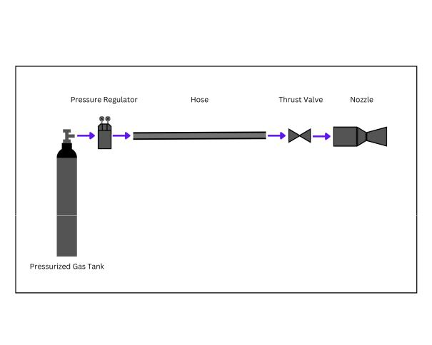

Figure 2 General physical model of the Rocket Hopper Demonstrator.

3.2 Mathematical Model

The following section describes how the physical model presented in the previous paragraph can be adapted into a mathematical model. It discusses the formulas that are later converted into code and ex-plains the reasons why they can be deemed applicable to describe the system’s components.

3.2.1 Fluid Simulation

Boundary Conditions Before the model for the system itself can be created, the boundary conditions need to be defined. As mentioned in the task descrip-tion, the regulator sets the pressure at the beginning of the hose to 11 bar. On the opposing side of the system, the nozzle exit, the boundary condition is defined by the atmospheric conditions at the test location. Here, the pressure is assumed to be 1 bar at a temperature of 293K. Due to the large volume of the tank and the hangar the tests are conducted in, it is assumed, that these conditions are constant and not affected by the launch of the hopper.

Hose To achieve accurate control over the resolution of the calculations for the hose, this component is split into a finite number of individual sections. The num-ber of sections can be set to the desired amount with the help of a variable in the Python code. Each section of the hose is represented by two separate equations in the mathematical model. First, the time derivative of the pressure in each pipe section is obtained by mod-eling the pipe sections as a capacity. For element 8 this leads to the following differential equation:

?⁄₈ | = | + d₈ | < | 1 | ⁄ | < |  | ” | (1)
3C |  |  | „ ⁄ ₈ | 1 | ⁄ |  | 8 | ” | (1)

2

In the next step, the time derivative of the massflow rate is calculated with the help of the inductor equation for each section:

Results The pressures and massflows in and through each of the components after one second simulation time are shown in figure 3. As the graph

<⁄₈ | = | „ | ? |  | ? |  | _ | <² |  | B86= | < |  | (2)
 | = | „ | ? |  | ? | ^{8‚1} _{2d8} 2 |  |  |  |  |  |  | (2)
3C |  | „ |  | 8 |  |  |  | ⁄ 8 |  |  | „ ⁄”” | ! | (2)

Both differential equations are later iteratively solved with the help of the Runge-Kutta 4 integrator, which is explained in more detail in section 3.3.3. The required densities d₈ in each pipe section are calculated by ap-plying the isentropic gas relations to the current pres-sure, the current density, and the new pressure in each section [6]. For each pipe section, the friction coeffi-cient _ is equal to 3, the length ! is equal to 8< divided by the number of segments and the cross-sectional area of the pipe is 111 22<<².

Fitting and Main Valve Both, the fitting before the main valve, and the main valve itself are modeled with the same approach. While the derivative of the pressure in the valve and the pipe is calculated analo-gously to the ones of the hose sections with equation

(1), the massflow rate is directly calculated by model-ing the resistance that the flow encounters while pass-ing through these components. This value is described by the following correlation:

 | 14
 | 12
 | 10
[bar]
Pressure | 8
Pressure |  |  |  |  |  | p Hose Segment 1
 |  |  |  |  |  | p Hose Segment 2
 | 6 |  |  |  |  | p Hose Segment 3
 |  |  |  |  |  | p Hose Segment 4
 |  |  |  |  |  | p Hose Segment 5
 | 4 |  |  |  |  | p Hose Segment 6
 |  |  |  |  |  | p Fitting entrance
 |  |  |  |  |  | p Valve entrance
 | 2 |  |  |  |  | p Nozzle entrance
 |  |  |  |  |  | p Nozzle exit
 | 0.0 | 0.2 | 0.4 | 0.6 | 0.8 | 1.0
 |  |  |  | Time [s]
 | 0.8 |  |  |  | mp Hose Segment 1
 | 0.8 |  |  |  | mp Hose Segment 2
 |  |  |  |  | mp Hose Segment 3
 |  |  |  |  | mp Hose Segment 4
 |  |  |  |  | mp Hose Segment 5
 | 0.6 |  |  |  | mp Hose Segment 6
[kg/s] |  |  |  |  | md Fitting
[kg/s] |  |  |  |  | md Valve
Flow |  |  |  |  | md Nozzle
Flow | 0.4
Mass
 | 0.2
 | 0.0
 | 0.0 | 0.2 | 0.4 | 0.6 | 0.8 | 1.0
 |  |  |  | Time [s]
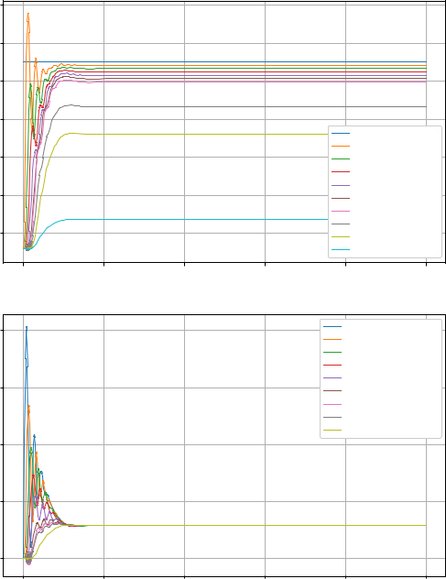

 |  |  |  |  |  |  |  |  |  | Figure 3 Pressure curve and mass flow from the fluid sim-
<⁄₁ = ^{s}„ ?₁ ?₂” |  | _ |  |  | B86= <₁ |  | (3) |  |  | Figure 3 Pressure curve and mass flow from the fluid sim-
 |  |  |  |  |  |  |  |  |  | ulation
 |  |  |  |  | 2d₁ | 2
 |  |  |  |  |  | „ ⁄ | ”

Analogously to the provided example, the _ of both components is assumed to be 100 times as large as the one of the hose sections. Furthermore, the di-mensions of the fitting were taken from the task de-scription where they are listed as 49.9mm length and 19.3mm diameter. Since the task description does not provide any information about the inner dimensions of the valve, they were assumed to be equal to the ones of the fitting.

Nozzle The fluid behavior in the nozzle itself is modeled in two different sections. First, the cham-ber area before the throat is modeled as a capacity. Similarly to the previous sections, equation (1) is used to calculate the time derivative of the pressure in the chamber. The volume of the chamber was provided as +_{2 0<14A} = 2<;. The massflow which leaves the chamber on the other hand can be calculated with the help of the Laval nozzle equation (7), which will be explained further in section 3.2.4.

shows, the system reaches a near-static state after approximately 0.15 sec. At this point, the pressure in the chamber of the nozzle reaches approximately 7.458 bar and the mass flows stabilize at 0.196 :6 B. Figure 3 displays the system for six simulated hose segments. In this figure, strong oscillations in the pressure and mass flow values can be seen before they stabilize around the aforementioned values. Appendix A.1 shows the same plot for five, ten, and twenty segments. Even though the readability of the plots with high segment values is reduced, it is still obvious, that such plots display considerably smoother pressure and mass flow curves. One likely explanation for this phenomenon is the fact that the values for the density are considered to be constant in each section of the hose - a circumstance that does not depict reality accurately. It leads to sharp pressure changes across the segment borders and can negatively influence the behavior of the differential equation system.

3

3.2.2 EcosimPro Validation

To validate the fluid simulation tool, EcosimPro was utilized. EcosimPro is a first-class simulation tool for modeling continuous-discrete systems. It is the official tool of the European Space Agency in multiple fields.

System Architecture Ecosim employs a robust system architecture that allows for comprehensive fluid dynamics simulations.
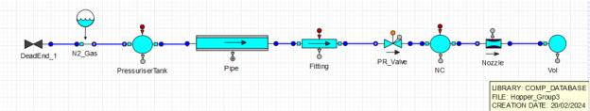

Figure 4 System architecture of the modeled Rocket Hop-per Demonstrator.

The real Nitrogen gas is introduced with the

N2_Gas and is stored in the Pressuriser Tank at 1110A. Then, the resistive Pipe acts as the flexible hose which allows the Nitrogen to be transported from the tanks to the Rocket Hopper Demonstrator. The length is set to 8< and the inner diameter to 19 3<< . As an interface between the pressure regulator valve (PR_Valve) and the flexible hose, a Fitting is introduced. This compo-nent has a length of 49<< and a diameter of 11 9<<. The PR_Valve is set to open always. Then, the fluid enters the nozzle chamber, NC, preceding the Nozzle where the thrust is generated. The throat area of the nozzle is calculated from the 9<< diameter condi-tion. The final Vol is used to simulate the environment, with a volume of 100000 00, the maximum allowed by Ecosim.

Results and Comparison with Fluid Simulation Analogous to the findings obtained in Figure 3 from the fluid simulation, Ecosim yields similar results. These are represented in Figure 14 and Figure 13.

The pressure evolution in Figure 13 indicates slightly lower pressures at the nozzle entrance in Ecosim compared to the fluid simulation. At the noz-zle entrance, the fluid simulation indicates pressures of around 710A, while Ecosim shows slightly lower pressures, averaging below 710A. Although the values are very close, it’s essential to consider Ecosim as the ground truth due to the instabilities observed in the integration process, represented as spikes in Figure 3. This is likely caused by the use of the Runge-Kutta 4 integrator. However, these errors do not significantly

affect the overall trend..

In terms of mass flow evolution (see Figure 14), Ecosim reports a smoother transient regime compared to the fluid simulation, with a mass flow of approx-imately 0 92:6 B versus over 0 1:6 B predicted by the fluid simulation.

Furthermore, a notable difference lies in the dura-tion of the transient regime until convergence. The fluid simulation typically takes around 0 1 seconds to converge, while Ecosim converges in a shorter tran-sient of only 0 03 seconds. This discrepancy may stem from the improved numerical methods and integration error handling in Ecosim, as well as a reduced time step size, contributing to faster convergence.

3.2.3 Main Control Valve Behavior

Since the remote-controlled main valve requires a small amount of time to open and close, an appropri-ate mathematical model is necessary to replicate this latency. As a first starting point, the transfer function of the valve was supplied to describe its behavior:
?02CD0; | = |  | 1 | (4)
 | = | 1‚02 B |  | (4)
?B4C
When examining this formula, it becomes evident that this behavior is equal to that of a PT1-bit with a time constant of ) = 0 2. To replicate the conditions in the valve, the control input ?_{B4C} is interpreted as a f step function with ?_{B4C} as its scaling factor . In the frequency domain, a PT1-bit with such an activation function can be simulated with the following equation:

. | „ | B | ” | = |  | 1 |  |  |  | ‚ | ) H„0” | (5)
 |  |  |  |  | )B‚1 |  |  |  | B | ‚ | )B‚1 | (5)

To transition back to the time domain, an inverse Laplace transformation is conducted, and the previ-ously defined model resulted in the following explicit equation:
?_{02CD0;} „C” = ?_{B4C} „1 4 | 0 2 | ” ‚ ?2DAA4=C ⁴ | 0 2 | (6)
 | C |  | C

Equation 6 is then used to directly describe the re-lation between the set pressure, the current absolute pressure, and the absolute pressure at the time of the next control input. Since the input frequency is defined as 60Hz, the time C which has passed since the last con-trol input is set to a constant ₆₀1 B. The outcome of the application of these equations to a real signal can be seen in figure 5. There, a random, noisy input signal

4

- _{B4C} is sent to the valve controller. ?_{02CD0;} shows the resulting absolute pressure, which is consequently sent to the nozzle.

the nitrogen. Formula 8 is used to simulate the con-nection between the diameter ratios of the throat and exit areas, and the Mach number [7]:

 | 10 | p
 |  | S et
 |  | p
 |  | Act ua l
 | 8
p[bar] | 6
 | 4
 | 2
 | 0
 | 0 | 2 | 4 | 6 | 8 | 10
 |  |  |  | t[s]
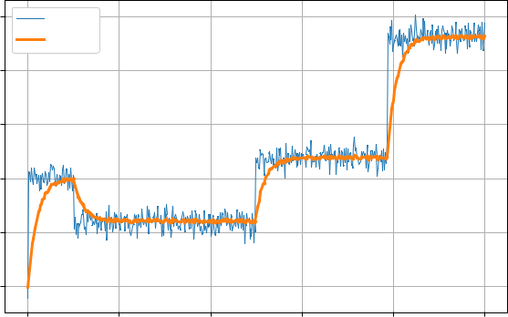

Figure 5 Valve for an exemplary noisy signal

Meanwhile, the problem could also be solved by uti-lizing the existing numeric integrator. A PT1-bit can also be modeled by an ODE, which could then be ap-proximated with the help of the already implemented Runge-Kutta 4 method. However, since the analyti-cal solution is available and could deliver more accu-rate results while being more efficient when it comes to computational power, it is decided to use the afore-mentioned strategy.

3.2.4 Nozzle

To determine the thrust, classic nozzle flow equations are used [7]. Besides the geometric dimensions, the exit pressure and the temperature from the previous section are known. The first value that needs to be determined is the massflow <⁄ through the nozzle. For this purpose, the following formula is utilized:

< = | _{C} ?_{C} |  |  |  |  | W ‚ 1 |  | W 1 | (7)
< = |  |  |  |  |  | W ‚ 1 |  | 2„W 1” | (7)
⁄ | q | ⁾C_{W}’ |  |  | „ | 2 | ”

Equation 7 creates a relation between the throat area _{C} , the specific heat capacity of nitrogen W, the specific gas constant of nitrogen ’, as well as the total pressure

?_{C} and total temperature )_{C} . Since the conditions in the nozzle are assumed to be a chocked flow, the Mach number is equal to 1. Furthermore, the remaining val-ues except the total temperature, are known from the previous sections or the task description. In the next step, the exit Mach number "₄ is calculated. The cal-culation is dependent on the geometric dimensions of the nozzle, as well as on the specific heat capacity of

 |  |  | W ‚ 1 |  |  |  | „ | 1 | ‚ | W | 1 |  | "2 | ” | W‚1
₄ |  |  | W ‚ 1 |  | W 1 |  | „ | 1 | ‚ |  |  |  | "2 | ” | 2„W 1”
₄ |  |  | W ‚ 1 |  | W 1 |  | „ | 1 | ‚ |  | 2
₄ | = | „ | W ‚ 1 | ” |  |  | „ |  | ‚ |  | 2 |  | 4 | ” |  | (8)
 |  |  |  |  | 2„W 1” |  | „ |  | ‚
 | = | „ | 2 | ” | 2„W 1” |  |  |  |  |  |  | "4 |  |  |  | (8)
C |  | „ | 2 | ”

While the formula describes the connection accu-rately, it cannot be solved for "₄ directly. Thus, a Newton algorithm with the following format is imple-mented to iteratively determine the value.

"48‚1^{="}48 | 5 „"₄ ₈” | (9)
"48‚1^{="}48 | 5 ⁰„"₄ ₈” | (9)
Depending on the initial value "₄ ₀ , this algorithm delivers two different Mach numbers. The lower re-sult is " = 0 582, leading to a subsonic flow. Since supersonic behavior was assumed, the higher result, "₄ = 1 548 is chosen as the more accurate one for the process. With the exit Mach number calculated, the following formulas are used to find the exit pressure
- ₄ and the exit temperature )₄:
?₄=?_{C} „1‚^{W} |  |  |  | 2 | ¹ _{"4}²”W 1 |  |  |  | (10)
 |  |  |  |  |  |  | W
)₄ =)_{C} „1‚ |  | W |  |  | 1 | "₄²” ¹ |  |  | (11)
 |  |  |  | 2 |  |  |  |  | (11)

Both formulas use a combination of the exit Mach number and the specific heat capacity to calculate the ratio between the total value and the exit value. While the total pressure, ? _{C} , is assumed to be the absolute pressure that was set by the main valve, the total tem-perature, )_{C} , is still unknown. However, once all vari-ables are combined in Equation 12 and Equation 13, it becomes evident that )_{C} is canceled out when the mass flow is multiplied by the exit velocity. Thus, this pa-rameter does not affect the thrust generation and does not need to be determined. As the last variable in the process, the flow velocity in the exit area needed to be determined. For this purpose, the exit Mach number was multiplied by the speed of sound, represented by the root of the product of the specific gas constant and the specific heat capacity of nitrogen, as well as the exit temperature:

E₄ = "₄^{p}W’)₄ (12)

Finally, the calculated values are combined with the ambient pressure ?₀ to calculate the generated thrust ₎ :

₎ =<+⁄₄‚„?₄ ?₀” ₄ | (13)

5

 |  |  |  |  |  |  |  |  |  |  |  |  |  |  | measuring resolution on the acceleration of 0 01 _{B2} ,
 |  |  |  |  |  |  |  |  |  |  |  |  |  |  |  |  |  | <
 |  |  |  |  |  |  |  | FThrust |  |  |  |  |  |  | when seen per second. This piecewise-defined func-
 |  |  |  | FR |  |  |  |  |  |  |  |  |  |  | tion is plotted in Figure 15.
 |  |  |  |  |  |  |  |  |  |  |  |  |  |  | Thrust Force Modelling ₎ | Connecting to Equa-
 |  |  |  |  | m |  |  |  |  |  |  |  |  |  | Thrust Force Modelling ₎
 |  |  |  |  |  |  |  |  |  |  |  |  |  |  | tion 13, the thrust is first derived from the nozzle flow
 |  |  |  |  |  |  |  |  |  |  |  |  |  |  | equations. To increase simulation speed for Reinforce-
g |  |  |  | FH |  |  |  | FG |  |  |  |  | x
g |  |  |  |  |  |  |  |  |  |  |  |  |  |  | ment Learning, a fitting is performed on the transfer
 |  |  |  |  |  |  |  |  |  |  |  |  |  |  | function from ?_{E0;E4} in bar to ₎ in Newton, which
 |  |  |  |  |  |  |  |  |  |  |  |  |  |  | requires no loss in accuracy due to the linear charac-
Figure 6 Physical model of the Rocket Hopper |  |  |  |  |  |  |  |  |  |  |  |  |  |  | teristics of this problem. To avoid negative values for
 |  |  |  |  |  |  |  |  |  |  |  |  |  |  | ₎ , a maximum comparison is applied.
3.2.5 Kinematics |  |  |  |  |  |  |  |  |  |  |  |  |  |  | ₎ „ ?_{E0;E4} »10A…” = max f0 < |  | ?_{E0;E4} ‚ =g »#…
The motion of the Hopper is described by the Newto- |  |  |  |  |  |  |  |  |  |  |  |  |  |  | with < = 10 600789 | = = | 9 503318
nian motion of = < 0 which expands to all present |  |  |  |  |  |  |  |  |  |  |  |  |  |  |  |  | (18)
 |  |  |  |  |  |  |  |  |  |  |  |  |  |  | A plot of the resulting thrust modeling can be found in
forces on the Hopper, being the thrust from the nozzle,
₎ , the gravitational force, , the force of the hose, |  |  |  |  |  |  |  |  |  |  |  |  |  |  | Appendix 16.
, and the resistance, ’. |  |  |  |  |  |  |  |  |  |  |  |  |  |  | 3.3 Numerical Model
 | 1 |  |  |  |  |  |  |  |  |  |  |  |  |  | 3.3 Numerical Model
G¥ = |  |  | „ ₎ |  |  |  |  |  |  |  |  |  | ‚ ’” | (14) | 3.3.1 ODE
G¥ = |  | <
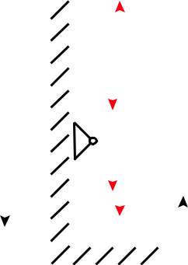

Gravitational Force Modelling The mass of the Hopper and the hose are combined into a constant gravitational force. The gravitational acceleration is set to standard gravity 6₀ = 9 80665< B ² as the ex-periment is carried out on Earth’s surface level.

The differential equation of motion is defined by the

ODE state vector H:

H = | H₂ |  | = | G⁄ | (19)
 | ^{H}1 |  |  | G

and its time derivative H⁄:

=< 6=„35‚1”:6 6₀=4413# (15)

Hose Force Modelling As the Hopper rises in the vertical position, the load increases from the ad-ditional hose mass. This force is modeled through a
spring behavior with constant : _{>B4} = 6# <.
„G”=: _{>B4} G | (16)

Resistance Force Modelling ’ The resistance is generally modeled by a constant force against the velocity of the Hopper. However, to avoid high-frequency alternating forces around G⁄ = 0, a transi-tioning section is defined where the force is changed linearly, which removes the step function at zero.
 |  | ( | B86=„G⁄” 10# |  |  |  |  |  |  |  | for j G⁄j ¡ 0 01
’ | G = | ( |  |  |  |  |  |  |  |  |  |  |  |  |  |  | B
 | „ ⁄” | ( |  | ^{j ⁄ j}< |  |  |  |  | B86= G 10# |  | for G 0 01 |  |  |  |  |  | B
 |  |  |  |  |  |  |  |  |  |  |  |  |  |  | <
 |  |  |  | G |  |  |  |  | „ ⁄” |  | j ⁄j |  |  |  | <
 |  |  |  | 0 01
 |  |  |  | 0 01 | B |  |  |  |  |  |  |  |  | (17)
The threshold of velocity to switch between those two sections is set to j G⁄j 0 01 < , which aligns with the
B

⁄ | G¥ |  | < „ ₎ |  |  |  | „H₁”’ „H₂””
H = | G⁄ | = |  | 1 |  |  | ^{H}2

(20)

Which together define position G, velocity G⁄, and ac-

celeration G¥ of the Hopper.

3.3.2 Restrictions

To prevent the Hopper from falling into a negative po-sition during the beginning of the simulation when the weight is supported by the ground, a restriction was made to the acceleration G¥ which sets it to zero if the position is at zero or below and the acceleration from the ODE would be negative.
G¥ = | ⁽G_{>34} |  |  | else |  | ¥ |  |  | (21)
 | 0 | < |  | if G | 0 | < and G_{>34} | 0 | <
 | 0 | 2 |  |  |  |  |  | 2
 |  | B |  |  |  |  |  | B
¥

This restriction prevents initial dropping into the negative realm as the thrust is built up, but not if ve-locity has already built up downwards. This scenario

6

would then correspond with a crash, which means the end of a meaningful simulation anyway.

3.3.3 Integrator

To solve the differential equation of motion which describes the system’s behavior, a numerical integra-tion method is utilized. The Runge-Kutta method is selected for this purpose, as it offers greater perfor-mance for the ODE system than explicit Euler through its higher order of degree. In particular, explicit Runge-Kutta of 4C order is used.

The selection of the integration stepsize is in-fluenced by the dynamics of the resistance force modeling, as needs to be small enough to land on the linear slope around zero velocity, otherwise alternating forces and instability are the result. Using a constant input of ?_{B4C} = 6 5 bar where the Hopper will reach a steady position, the accelerations G¥ are plotted for multiple integration stepsizes in Figure 7.
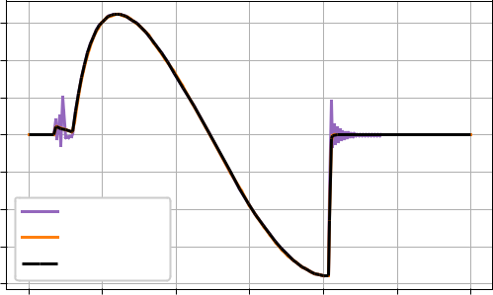

 | 0.015
 | 0.010
s²] | 0.005
x [m/ | 0.000
x [m/ | 0.005
 | 0.010 | h=1/60 s
 | 0.015 | h=1/120 s
 | 0.015 | h=1/600 s
 | 0.020
 | 0 | 50 | 100 | 150 | 200 | 250 | 300
 |  |  |  | Time [steps]

Figure 7 Acceleration over multiple integration stepsizes

Instabilities are visible for = ₆₀¹ B. Otherwise, the values are not changing from a reduced integration stepsize from ₁₂₀¹ B to ₆₀₀¹ B which proves convergence and the integration stepsize of = ₁₂₀¹ B is selected.

3.3.4 Simulation

The interaction strategy between the simulation and the controller is driven by the update frequency of the sensors or the Rocket Hopper. Hereby all sensors (G G¥ ?) share a sampling rate of 60 Hz, as well as the actor ?_{B4C} with 60 Hz as the maximum update fre-quency. This leads to the decision to also base the in-teraction of the controller on 60 Hz, which has the ben-efit of processing the absolute newest available data for the controller input.

Starting the controller with a state and delivering an action in the next update implies, that in the real world, the controller has roughly 16 ms time to compute the action.

3.4 Controller

3.4.1 General Description of Architecture

The TD3 actor-network is composed of two linear (dense) hidden layers of 16 neurons whereas the critic network shares the same structure but with 27 neurons. The reward function 5_{A} is a Gaussian distribution de-pending on the control error G as stated in Equation 22 with f = 0 5.
5_{A} „ G” = p |  | 2cf² | 4G ? | 2 |  |  | _{f} |  |  | ! | (22)
 |  | 1 |  | 1 |  |  |  | G |  | 2

Exploration vs Exploitation Achieving high re-wards requires a balance between exploration and ex-ploitation. The agent must exploit learned knowledge from the environment while exploring new actions for future strategies [8]. Various strategies, such as those compared by Plappert [9] and Lilicrap [3], exist for continuous action spaces. The Ornstein-Uhlenbeck Process (OUP) noise is preferred for its smoothness in exploration, particularly suitable for continuous con-trol tasks [3].

To incorporate exploration, OUP adds noise smoothly, as described by the stochastic differential equation:

3G_{C} = \G_{C} 3C ‚ f3,_{C} | (23)
where \ ¡ 0 and f ¡ 0 are parameters and ,_{C} denotes the Wiener process.

Hyperparameter Settings Hyperparameters not only affect the reinforcement learning algorithm but also the exploration strategy and the environment. DDPG generally provides good results in continuous control problems [10] but is more sensitive to numer-ous hyperparameters than other algorithms [11].

These are grouped into DDPG, Exploration, and Environmental Hyperparameters.

3.4.2 Sensitivity Analysis

Performing sensitivity analysis in hyperparameter tun-ing involves systematically exploring how changes in these values impact the model’s performance metrics. It provides valuable insights into the robustness of the

7

model and helps identify optimal configurations for achieving the best results.

Hyperparameter Optimization Methods The suitable hyperparameters are problem-specific and the optimal hyperparameter combination is often non-intuitive. The widespread manual choice of hyper-parameters therefore requires experience and is time-consuming [12].

Several strategies are presented that can be followed depending on the approach. There are Model-free Ap-proaches and Model-based Approaches, but the focus remains on the former.

- Grid Search - discrete, grid-shaped subset instead of the entire parameter space.

- Random Search - selects hyperparameters from the equally distributed search space.

- Optuna - employs advanced optimization tech-niques, such as Bayesian optimization, to adap-tively explore and intensify the search in areas of the parameter space with high potential.

Bergstra and Bengio proves that the random choice of hyperparameter combinations is more efficient than searching a grid subset [13] Optuna however is better than a Random Search, which is an improvement from the initial DDPG approach and hyperparameter tun-ing. These approaches prevent the convergence into local optima but are extremely time-consuming due to the curse of dimensionality in large parameter spaces.

Random Search To conduct the sensitivity anal-ysis, a random sample from a log-uniform distribu-tion was generated for key hyperparameters, namely

;40A=8=6_A0C4_02C>A, ;40A=8=6_A0C4_2A8C82, and 4G ?;>A0C8>=_=>8B4 . The log-uniform distribution is chosen for its ability to explore different orders of mag-nitude efficiently. The range used to perform the ran-dom search is provided in Table 1.

Table 1 Ranges employed for Random Search

Hyperparameter | Range
Learning Rate (Actor) | »0 0001 0 0005…
Learning Rate (Critic) | »0 001 0 05…
Exploration Noise | »01 3…

Random Search Plot Two graphical represen-tations are provided to illustrate the outcomes:

Figure 8 displays multiple line plots, each depicting the evolution of episode rewards over time for specific hyperparameter settings. The x-axis represents the episode number, while the y-axis shows the corre-sponding reward achieved during training.

Observations from Figure 8 reveal three general be-haviors. Line plots with steep rewards indicate highly effective configurations leading to rapid learning and substantial rewards. Line plots approaching zero sug-gest a bimodal distribution in the effectiveness of set configurations. Additionally, most line plots plateau after approximately 100 episodes, indicating diminish-ing returns from further training. Some configurations exhibit slower learning but lack significant reward im-provement.
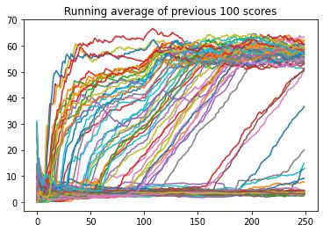

Figure 8 Random Search Results with 100 random log-uniform distributed samples.

Scatter Plot of Rewards The observed pattern in the scatter plot in Figure 9, where almost all con-figurations either obtain the maximum reward or al-most zero, suggests a distinctive bimodal distribution in the effectiveness of the hyperparameter configura-tion. This proves the hypersensitivity of DDPG mod-els to hyperparameter tuning. The bimodal behavior emphasizes the existence of configurations that lead to highly successful, near-optimal performance, and sub-optimal or negligible learning configurations.

Upon analyzing Figure 9, it becomes evident that certain hyperparameter configurations stand out as highly effective. A distinct cluster of configurations is observed and included in Table 2.

8

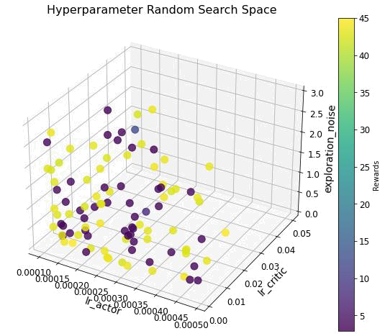

Figure 9 Scatter Plot of Rewards obtained for the 100 ran-dom log-uniform distributed samples.

Table 2 Hyperparameter Settings and Highest Reward with DDPG Random Search

Hyperparameter | Value
Learning Rate (Actor) | 0.00024188
Learning Rate (Critic) | 0.0001
Exploration Noise | 0.28878
Highest Reward | 43.86

3.4.3 TD3 Optimization with Optuna

After determining the optimal hyperparameter set-tings for DDPG with the random search, the settings were then transferred to TD3 and further hyper-parameter tuning was performed with the Optuna framework. Optuna allows for a bigger number of hyperparameter tuning, and pruning, allowing for better computational resource allocation. Figure 19 demonstrates how different hyperparameters spread to find the highest total reward, while Figure 19 shows the importance of each hyperparameter. Certain hyperparameters show a local accumulation, i.e. gamma, whereas similar optima are found for diver-sified values in other hyperparameters, i.e. learning rates.

By adopting these settings for TD3, a baseline for its performance was established, evaluating its effec-tiveness compared to DDPG, and enabling a system-atic comparison of the two algorithms in reinforce-ment learning tasks.

A final comparison between the different controllers implemented is collected in Table 4. Even though TD3

Table 3 Hyperparameter Settings and Highest Reward with TD3 Optuna

Hyperparameter Value

_{Learning Rate} Actor 0.00086479 Critic 0.03483899
Layer Size |  | Actor | 16
Layer Size |  | Critic | 27
Tau |  |  | 0.0066
Gamma |  |  | 0.9867
Batch Size |  |  | 42
Highest Reward |  |  | 141.35

proves as an exponential improvement upon DDPG, it is still falling behind a PID controller.

Table 4 Reinforcement Learning Controller Comparison with PID

Reward | Value
DDPG | 43.86
TD3 | 141.35
PID (Ground Truth) | 157.6

3.4.4 Robustness

Robustness is crucial for evaluating control algorithms and deep learning models. According to Moos et al. [14], robustness in reinforcement learning (RL) refers to the ability to handle variations or uncertainties in the environment’s dynamics. Training RL models with noise, such as Ornstein-Uhlenbeck Process (OUP), en-hances robustness by allowing networks to adapt to noisy signals [14]. Moreover, proper selection of hy-perparameters significantly impacts model robustness, with methods like random search and grid search prov-ing effective [14]. Additionally, quick and clear train-ing convergence serves as an indicator of robust sys-tems, as observed in the DDPG network [14]. To fur-ther validate robustness, methods like the Monte-Carlo method can be employed [15].

3.4.5 Interfaces

As the interface to the Hopper includes raw integer values, the uint12 range »0 4095… is mapped to »0 7… bar and reverse. Communication goes over pyserial by a baud rate of 115200 which transfers an utf-8 en-coded string of a length around 33 (e.g. ”< 74282: 9.73: 1.21: 1980: 0: 0 >”). This gives an estimation of 33 bytes per transfer which would need 2.3 ms in transfer time via the mentioned baud rate. Addition-ally, the shifted zero point in position is compensated

9

Which is mapped to the action space of ?_{<8=} = 0 to ?_{<0G} = 7 by a sigmoid function f„G”.
by subtracting 0.11 m in altitude before it is handed to the controller.

4 Results

4.1 TD3 Controller

4.1.1 PID Baseline

A PID controller was created as a baseline for the ex-ample scenario to reach a static target G_{C 0A 64C} = 2 from
- = »0 0…. The chosen value D„C” is defined by:

D„C” = _{p} 4„C” ‚ _{i} „₀ | 4„g”dg ‚ | _{d} ^{d} _{d}„_{C} ” (24)
 | C |  | 4 C

4.1.4 Test Campaign

During the test campaign, 4 runs are attempted, where different types of errors occurred. In run 1, due to a full throttle command, a comparison between a full throt-tle simulation can be drawn, which showed consider-able differences (Figure 23). In run 2 and 4, the action space of the network was not mapped correctly, yet still some valve behaviour remains unexplained (Fig-ure 25). In run 3, a constant resting on the initial posi-tion is recorded, which gives a great condition to mea-sure the noise of the acceleration sensor. The follow-ing errors and learnings are summarized:

- Actions have been recreated from the recorded state instead of logged directly.

- Descent maneuver was triggered immediately.

 |  | • | Wrong mapping of pressures between the integer
f„G” = | 1 | (25) | value of 10 bar to the action space of the network
f„G” = |  | (25) | of 7 bar.
f„G” = | 1‚4 ^{G} | (25) | of 7 bar.

?_{B4C} „C” = f„D„C”” „ ?_{<0G} ?_{<8=}” ‚ ?_{<8=} | (26)
Through manual adjustment, the constants | _{p} = 50,
- = 0 08 and _{d} = 1000 have been determined, which gives a reward score over a simulation time of 5 B with reward evaluation every ₆₀¹ B. This reward score of 157 6 gives an orientation of what perfor-mance can be achieved, which sets the baseline for the TD3 controller in the benchmark scenario.

- Maximum pressure, thrust, and acceleration have been overestimated in the simulation

- Acceleration noise (f = 0 67 < B² measured in run 3) is largely transferred into the action.

- Remaining unexplained lack of response of the valve under some conditions.

4.1.2 Results after Hyperparameter Tuning

After extended training with the selected hyperparam-eter values described in subsubsection 3.4.2, the re-ward score measured 142 in the benchmark scenario. This score still falls behind the PID baseline of 157.6 but still managed to achieve a decent control under simulation.

In Figure 24 can be seen the simulation of a target height of 2 m together with a descent maneuver. The linear decrease of the target height was implemented due to overshooting.

4.1.3 Real Time Capability

In the deployment stage the actor and critic are loaded from a file and run in forward mode. The time to com-pute an action is tested over 1 million actions (CPU: In-tel i5-6600K) which resulted in a mean execution time of 0.19 ms. Together with the communication time of 2.3 ms to be 2.5 ms, it fits the 16.33 ms time window of a 60 Hz control with plenty of margin.

5 Conclusion

Only with the final model, stability is obtained in the simulation, however with considerable over- and under-shooting, but no positional oscillation. In the test campaign, stability could not be demonstrated. The concluded reasons for this are the wrong action space mapping and the highly oscillating commands to the valve, which are induced by the sensor noise. One solution would be to train the model without the infor-mation of the acceleration sensor, so a steady control set value is achieved.

During the development of the RL model, selecting the appropriate reward function has proven to be vital. As the control requirements have to be converted into feedback to the network, while still featuring a contin-uous landscape to ensure optimization conditions.

Advances are made by the transition to TD3, while still a hypersensitivity on the hyperparameter settings is present. Only under extended randomized search, a model is obtained that compares with 142 as reward score to the PID controller of 157.6.

10

Open Access The source code with all processing

steps and the Python Notebooks can be found in the

Git-Repository.

11

References

- Gabriel Cassimiro. A deep dive into actor-critic methods with the ddpg algorithm. Geek Culture, 14.4.2023.

- Nesma M. Ashraf, Reham R. Mostafa, Rasha H. Sakr, and M. Z. Rashad. Optimizing hyperpa-rameters of deep reinforcement learning for au-tonomous driving based on whale optimization algorithm. PLoS ONE, 16(6):e0252754, 2021.

- Timothy P. Lillicrap, Jonathan J. Hunt, Alexan-der Pritzel, Nicolas Heess, Tom Erez, Yuval Tassa, David Silver, and Daan Wierstra. Contin-uous control with deep reinforcement learning.

- Haifei Zhang, Jian Xu, Jian Zhang, and Quan Liu. Network architecture for optimizing deep deterministic policy gradient algorithms. Computational Intelligence and Neuroscience, 2022:1117781, 2022.

- Scott Fujimoto, Herke van Hoof, and David Meger. Addressing function approximation er-ror in actor-critic methods, 2018.

- Isentropic flow equations, 30.03.2024.

- Nancy Hall. Rocket thrust equations, 2021.

- Richard S Sutton, Andrew G Barto, et al. Intro-duction to reinforcement learning, volume 135. MIT press Cambridge, 1998.

- Matthias Plappert, Rein Houthooft, Prafulla Dhariwal, Szymon Sidor, Richard Y Chen, Xi Chen, Tamim Asfour, Pieter Abbeel,
and Marcin Andrychowicz. Parameter space noise for exploration. arXiv preprint arXiv:1706.01905, 2017.

- Yan Duan, John Schulman, Xi Chen, Peter L Bartlett, Ilya Sutskever, and Pieter Abbeel. Rl ˆ2: Fast reinforcement learning via slow reinforce-ment learning. arXiv preprint arXiv:1611.02779, 2016.

- A Rupam Mahmood, Dmytro Korenkevych, Gautham Vasan, William Ma, and James Bergstra. Benchmarking reinforcement learning algorithms on real-world robots. In Conference on robot learning, pages 561–591. PMLR, 2018.

- Roman Liessner, Jakob Schmitt, Ansgar Dieter-mann, and Bernard Bäker. Hyperparameter op-timization for deep reinforcement learning in ve-hicle energy management. In ICAART (2), pages 134–144, 2019.

- James Bergstra and Yoshua Bengio. Random search for hyper-parameter optimization. Jour-nal of machine learning research, 13(2), 2012.

- Janosch Moos, Kay Hansel, Hany Abdulsamad, Svenja Stark, Debora Clever, and Jan Peters. Ro-bust reinforcement learning: A review of foun-dations and recent advances. Machine Learning and Knowledge Extraction, 4(1):276–315, 2022.

- Kimia Vahdat and Sara Shashaani. Robust output analysis with monte-carlo methodology.

12

A Appendix

A.1 Fluid Simulation
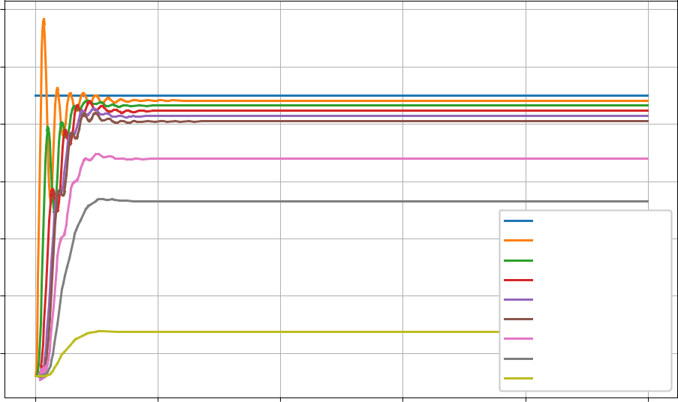

Pressure [bar]

14

12

10

8

6

4

2

p Hose Segment 1

p Hose Segment 2

p Hose Segment 3

p Hose Segment 4

p Hose Segment 5

p Fitting entrance

p Valve entrance

p Nozzle entrance

p Nozzle exit

0.0 0.2 0.4 0.6 0.8 1.0

Time [s]
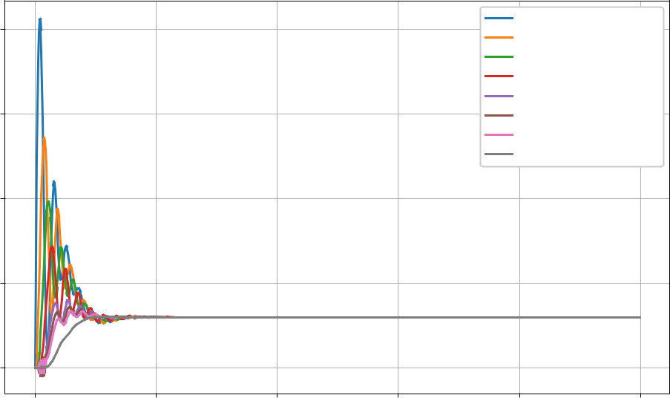

Mass Flow [kg/s]

0.8

0.6

0.4

0.2

0.0

mp Hose Segment 1

mp Hose Segment 2

mp Hose Segment 3

mp Hose Segment 4

mp Hose Segment 5

md Fitting

md Valve

md Nozzle

0.0 0.2 0.4 0.6 0.8 1.0

Time [s]

Figure 10 Pressure curve and mass flow from the fluid simulation with five hose segments

13

Pressure [bar]

Mass Flow [kg/s]

12

10

8

6

4

2

0.7

0.6

0.5

0.4

0.3

0.2

0.1

0.0

p Hose Segment 1
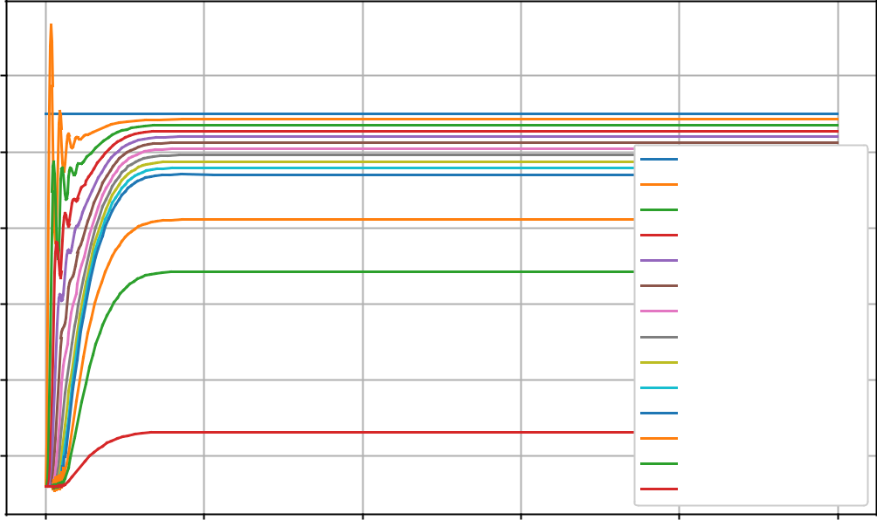

p Hose Segment 2

p Hose Segment 3

p Hose Segment 4

p Hose Segment 5

p Hose Segment 6

p Hose Segment 7

p Hose Segment 8

p Hose Segment 9

p Hose Segment 10

p Fitting entrance

p Valve entrance

p Nozzle entrance

p Nozzle exit

0.0 0.2 0.4 0.6 0.8 1.0

Time [s]
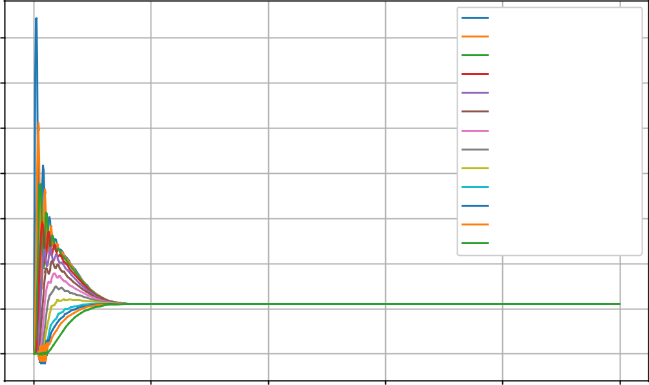

mp Hose Segment 1

mp Hose Segment 2

mp Hose Segment 3

mp Hose Segment 4

mp Hose Segment 5

mp Hose Segment 6

mp Hose Segment 7

mp Hose Segment 8

mp Hose Segment 9

mp Hose Segment 10

md Fitting

md Valve

md Nozzle

0.0 0.2 0.4 0.6 0.8 1.0

Time [s]

Figure 11 Pressure curve and mass flow from the fluid simulation ten five hose segments

14

Pressure [bar]

Mass Flow [kg/s]

12

10

8

6

4

2

0.5

0.4

0.3

0.2

0.1

0.0

p Hose Segment 1
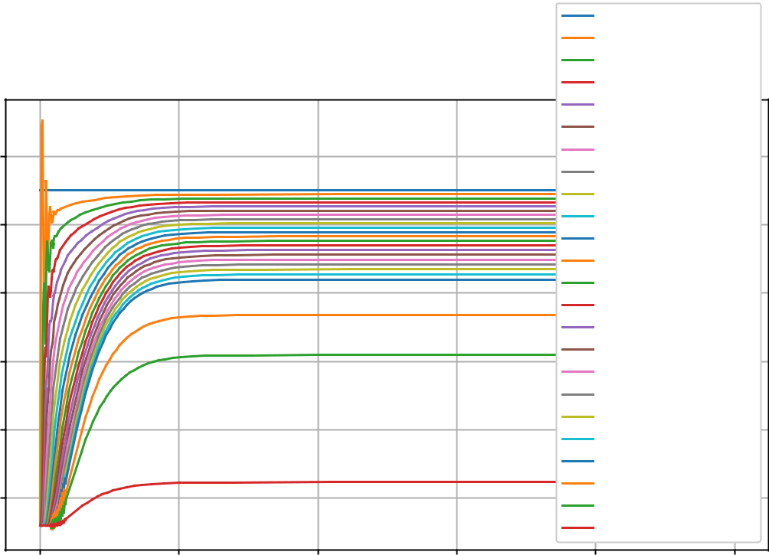

p Hose Segment 2

p Hose Segment 3

p Hose Segment 4

p Hose Segment 5

p Hose Segment 6

p Hose Segment 7

p Hose Segment 8

p Hose Segment 9

p Hose Segment 10

p Hose Segment 11

p Hose Segment 12

p Hose Segment 13

p Hose Segment 14

p Hose Segment 15

p Hose Segment 16

p Hose Segment 17

p Hose Segment 18

p Hose Segment 19

p Hose Segment 20

p Fitting entrance

p Valve entrance

p Nozzle entrance

p Nozzle exit

0.0 | 0.2 | 0.4 | 0.6 | 0.8 | 1.0
 |  |  | Time [s]
 |  |  |  | mp Hose Segment 1
 |  |  |  | mp Hose Segment 2
 |  |  |  | mp Hose Segment 3
 |  |  |  | mp Hose Segment 4
 |  |  |  | mp Hose Segment 5
 |  |  |  | mp Hose Segment 6
 |  |  |  | mp Hose Segment 7
 |  |  |  | mp Hose Segment 8
 |  |  |  | mp Hose Segment 9
 |  |  |  | mp Hose Segment 10
 |  |  |  | mp Hose Segment 11
 |  |  |  | mp Hose Segment 12
 |  |  |  | mp Hose Segment 13
 |  |  |  | mp Hose Segment 14
 |  |  |  | mp Hose Segment 15
 |  |  |  | mp Hose Segment 16
 |  |  |  | mp Hose Segment 17
 |  |  |  | mp Hose Segment 18
 |  |  |  | mp Hose Segment 19
 |  |  |  | mp Hose Segment 20
0.0 | 0.2 | 0.4 | 0.6 | md Fitting | 1.0
 |  |  |  | 0.8 | 1.0
 |  |  | Time [s] | md Valve
 |  |  |  | md Nozzle
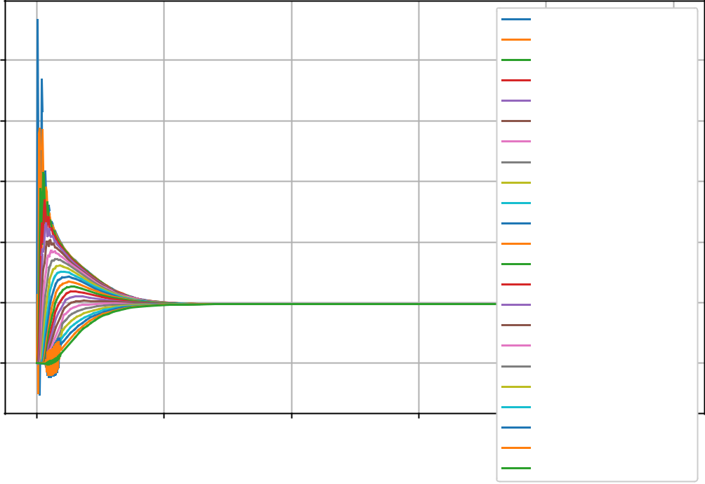

Figure 12 Pressure curve and mass flow from the fluid simulation with twenty hose segments

15

A.2 Ecosim Results
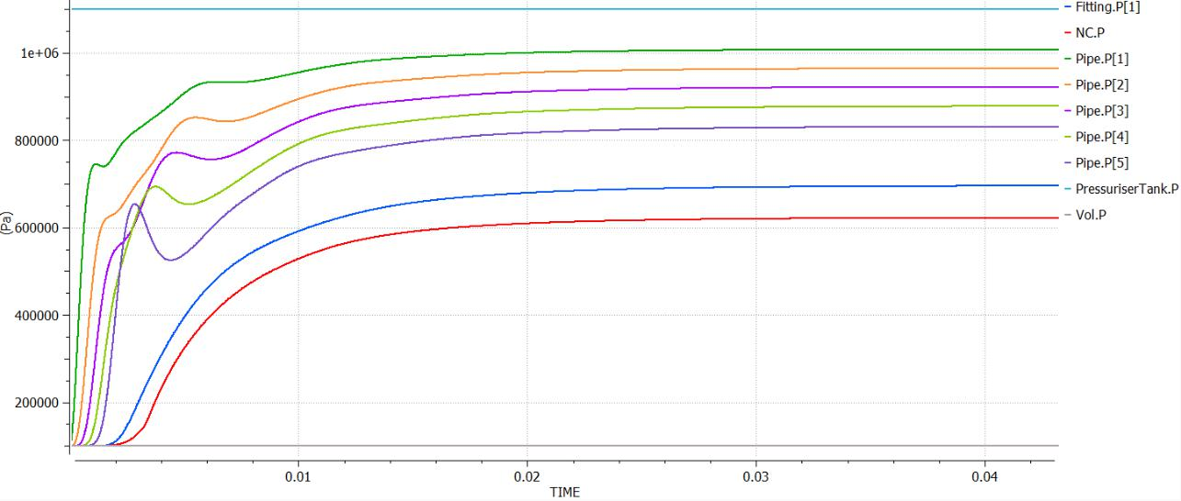

Figure 13 Pressure evolution through all components in the system provided for the Ecosim simulation of the Rocket Hopper Demonstrator.
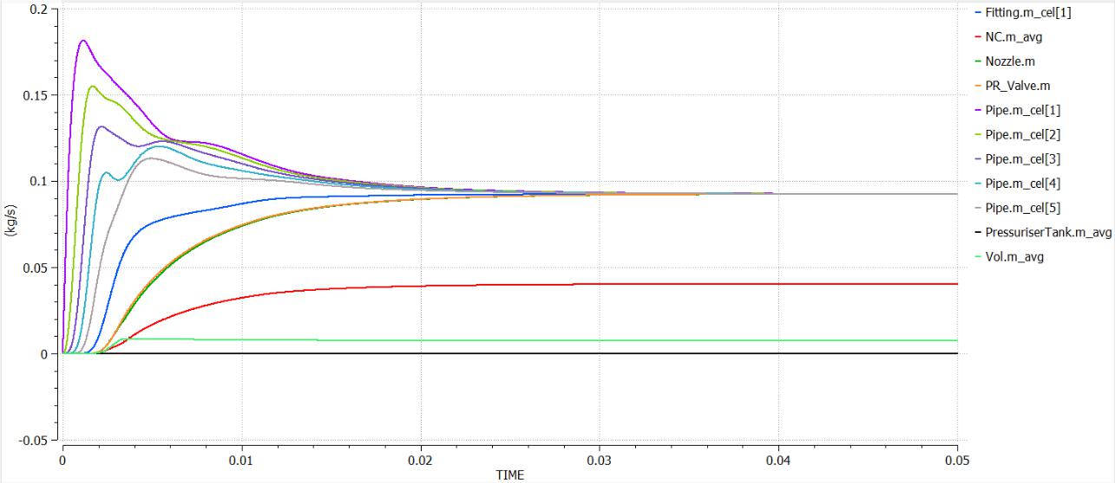

Figure 14 Mass Flow evolution through all components in the system provided for the Ecosim simulation of the Rocket Hopper Demonstrator.

16

A.3 Modelling A.5 Network Structure
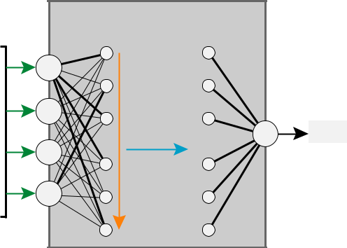

 | 10 | F (x)
 |  | R
 | 5
F [N] | 0
 | 5
 | 10
 |  | 0.04 | 0.02 | 0.00 | 0.02 | 0.04
 |  |  |  | x[m/ s]
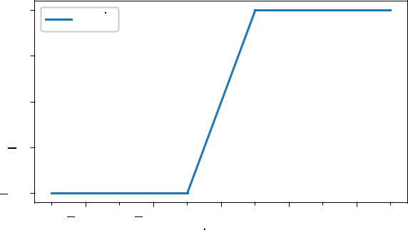

Figure 15 Resistance modelled ’ „ G⁄” with smoothing
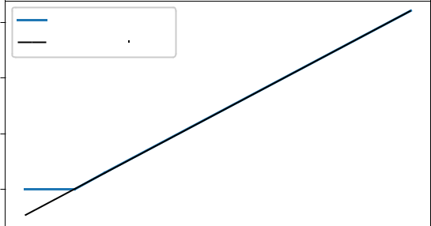

60 | F (p |  | )
60 | T | valve
 | f_{fi t} (p ) =m p + n
40
F [N]
20
0
0 |  | 1 | 2 | 3 | 4 | 5 | 6 | 7
 |  |  |  | p[b ar]
 |  |  |  | valve

Figure 16 Thrust modeled ₎ „ ?_{E0;E4}” with restrictions

A.4 Simulation Interaction

TD3 Network

 |  |  |  |  | action |  | state |  |  | action |  |  |  |  |  |  |  |  |  |  |  |  |  |  |  | state |  |  |  |  |  | action |  | state |  |  |  | action
state
 |  |  |  |  |  | sim_step |  |  |  |  |  |  |  |  | sim_step |  |  |  |  |  |  |  |  |  |  |  |  |  |  |  |  |  |  | sim_step
 |  |  |  |  |  | sim_step |  |  |  |  |  |  |  |  |  |  |  |  |  |  |  |  |  |  |  |  |  |  |  |  |  |  |  | sim_step |  |  | ...
 |  |  |  |  |  |  |  |  |  |  | h
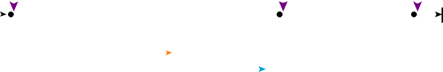
t_step = 1/60 s

Figure 17 Simulation structure and controller interaction

 | Actor Network
 | fully connected, dense layers
^{x}target |  | n
x |  |  |  | action
 | ... | ... | ... | map
a | ... | ... | ...
a |  | k | [-1..1] | [0..7]
^{p}actual
state
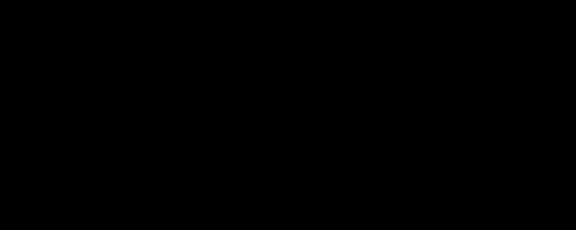
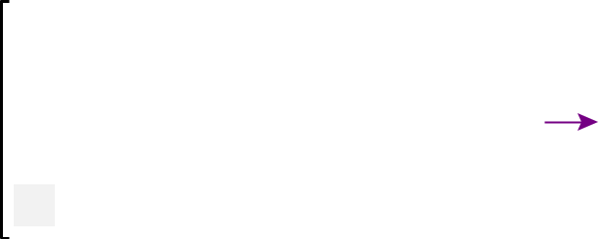

Figure 18 Internal structure of the actor with k hidden lay-ers and n number of neurons. (: = 2, = = 16)

17

A.6 Optuna Results
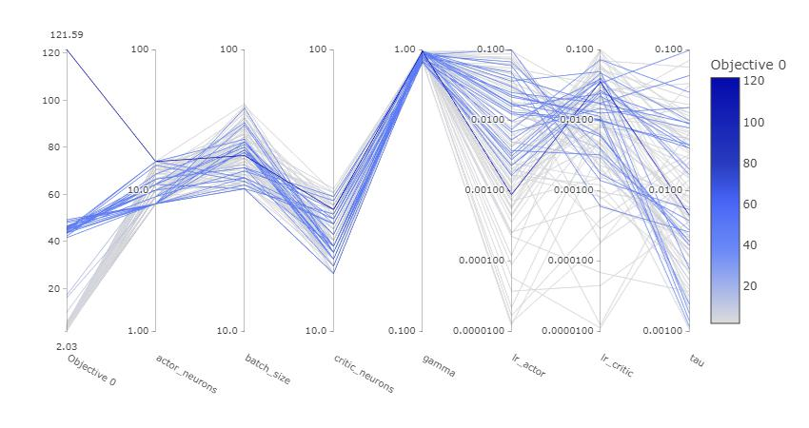

Figure 19 TD3 Hyperparameter optimization with Optuna.

18

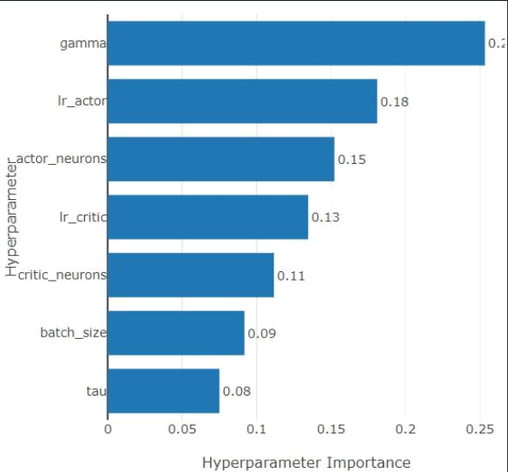

Figure 20 TD3 Hyperparameter importance.
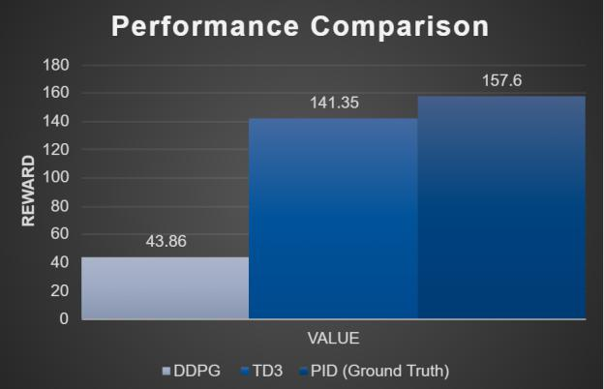

Figure 21 Total Reward Comparison between DDPG, TD3,

and PID controller.

19

A.7 Simulation and Test Campaign

Results
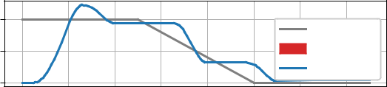

x [m]

p [bar]

2
 | x_target
1 | error [m]
 | position
0
5
 | p_set
 | p_actual
0
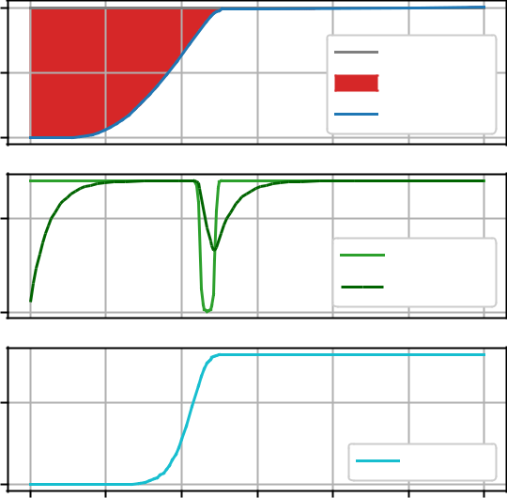

0.5
 |  |  |  |  | reward
0.0
0 | 50 | 100 | 150 | 200 | 250 | 300
 |  | Time [steps]

x [m] | 2 | x_target
x [m] | 1 | error [m]
 |  | position
 | 0
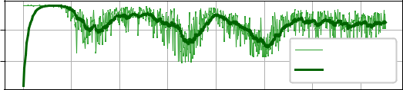

p [bar] | 5.0
p [bar] | 2.5 | p_set
 | 2.5 | p_actual
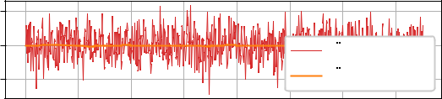

[m/ s²] | 2.5
[m/ s²] | 0.0 | x_with_ noise
x |  | x_true
 | 2.5 | x_true
 | 1.0
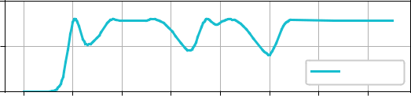

0.5

reward

0.0

0 | 2 | 4 | 6 | 8 | 10 | 12 | 14
 |  |  |  | time [s]

Figure 22 Simulation of the baseline PID controller | Figure 24 Simulation with descent maneuver of the final
Figure 22 Simulation of the baseline PID controller | trained model
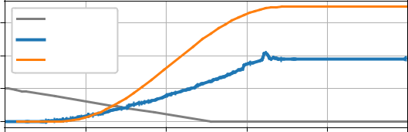

Position[m] | 3 | x_target |  | Position[m]
Position[m] |  | x_actual |  | Position[m]
Position[m] | 2 | x_sim |  | Position[m]
 | 1
 | 0
Pressure[bar] | 10 |  |  | Pressure[bar]
Pressure[bar] | 5 |  | p_set | Pressure[bar]
 |  |  | p_actual
 |  |  | p_sim
 | 0
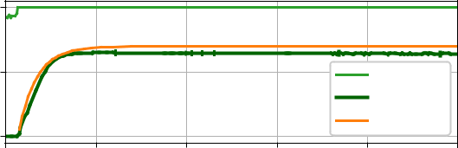

Acceleration [m/s²] | 150
Acceleration [m/s²] |  |  |  |  |  | x_read
Acceleration [m/s²] | 100 |  |  |  |  | Acceleration[m/s²]
Acceleration [m/s²] | 50 |  |  |  |  | Acceleration[m/s²]
Acceleration [m/s²] | 0 |  |  |  |  | Acceleration[m/s²]
 | 0 | 1 | 2 | 3 | 4 | 5
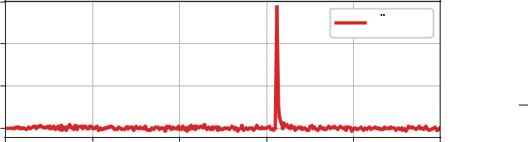

time [s]

2

1

0

10

5

0

10

0

10

x
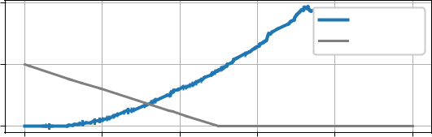

x_target
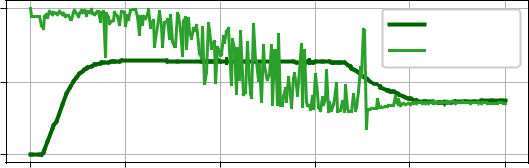

p_actual

p_set
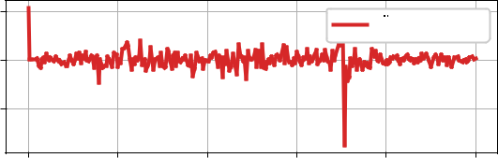

x_measure d

0 1 2 3 4 5

time [s]

Figure 23 Test Campaign Run #1, with wrong mapping, re-sulted in full throttle compared with simulation

Figure 25 Test Campaign Run #4, with wrong action space mapping and unexplained lack of response

20

